Stress Detector And Reducer Wearable Device Using IOT

Dr.LJabaSheela. 1, V.Monica2, Z. Sabarna Barhan2.,V.Madhusri2

# 1(Professor, Computer Science Engineering, Panimalar Engineering College/ Anna University, Chennai, India)

2(*Computer Science Engineering, Panimalar Engineering College/ Anna University, Chennai, India)*

***Abstract*— wearable devices have recently received hefty interest because of their nice promise for a inordinateness of applications. a large vary of wearable sensors are being developed for period non-invasive watching. This project provides comprehensive review of sensors used in wrist-wearable devices, methods used for the visualization of parameters measured as well as methods used for intelligent analysis of data obtained from wrist-wearable devices. Aim of our proposed system is to build a device used to identify human stress level and to reduce it. Here we are using the galvanic sensor, heart rate sensors and ECG sensors are used to identify human stress level by monitoring the heart rate, skin resistance level and pulse rate. We are using IR LED (9000nm – 12000nm) light allows light energy to penetrate one to three inch- es into your muscle tissue. Using energy our muscle creates their own heat .It is one of the best ways to relax. The collected sensors data will be displayed in the web page, LED screen using IoT (Internet of Things). Suggestions to be placid will be displayed and recently collected sensors data will be displayed in android applications**

***Index Terms***— ***Galvanic sensors, Heart rate sensors , ECG sensors ,IR LED,LED display*.**

## I.INTRODUCTION

Stress detection is the proceeding analysis subjectamong researchers. Diversity automation evolves on person stress detection using wearable sensors. Here we are using the galvanic sensor, heart rate sensors and ECG sensors .These sensors are used to identify hu- man stress levels by monitoring the heart rate, skin resistance level. Monitoring the stress with individual parameter is sufficient for exact detection of stress. However, using multiple parameter aids in superior detection of stress. A combination of parameters such as heart rate, skin resistance level and pulse rate additionally increases the accuracy.

Stress reduction with physical activity in today’s busy life is difficult. We are using IR LED (9000 nm-12000 nm) light allows light energy to penetrate one to three inches into your muscle tissue. Using energy our muscle creates their own heat.It is one of the best ways to relax.The collected sensors data will be displayed in the web page,LED screen using IoT (Internet of Things). estions to be placid will be displayed and recently collected sensors data will be displayed in android applications.

The Existing stress detection system was performed in the laboratory environments, while the current analysis continues on real-life environments. The Current EEG (Electroencephalogram) measuring devices are obtrusive for individuals and they are not applicable to daily life routines. So we don’t have an efficient device for reducing the stress level. To overcome the disadvantage in the existing system we are going to propose this automation detection system.This is cost efficient compare to all the other existing

systems.

## RELATED WORKS

1. Nurdina Widanti; Budi Sumanto; Poppy Rosa; M. Fathur Miftahudin Automatic Stress Detection Using Wearable Sensors and Ma- chine Learning: A Review.(2020)Advantage: Detecting Stress of an individual with the help of wearable sensors and machine learning algorithms are effective and affordable. Disadvantage: Used multiple features correlated with each other increases computation time and used some costly commercial devices for physiological signal collection. [https://ieeexplore.ieee.org/document/9225692.](https://ieeexplore.ieee.org/document/9225692)
2. Murat Yuksel; Wei Wang; Shafaq Chaudhry; Damla Turgut; Naim KapucuChallenges and Opportunities in Utilizing IoT-Based Stress Maps as a Community Mood Detector(2019). Advantage: a time series of national maps of happiness and negative emo- tions.Disadvantage: Need to aggregate data and transfer it with a high enough frequency to adhere to the real-time nature of collecting and monitoring stress data. [**https://ieeexplore.ieee.org/document/9032995**](https://ieeexplore.ieee.org/document/9032995)
3. Bhagyashree Shirke; Jonathan Wong; Kiran George. Acute Mental Stress Measurement using Brain-IoT System (2019). Ad- vantage: Non-invasive method for individuals to diagnose and cope with their stress levels. Disadvantage: reading may be slightly inaccurate by EEG headset due to the inference of the hair and high sensitivity to muscle movement.<https://ieeexplore.ieee.org/document/8998992>
4. Vasilii G. Arkhangelsk Sergey A. Alyushin Alexander V. AlyushinDevelopment and Analysis of Analog-Digital Neural Net for Speech Stress Detection(2018)Advantage: supports self-organization process in speech stress detection during speech analy- sis.Disadvantage: Cannot able to detect stress by body condition. <https://ieeexplore.ieee.org/document/8317460>
5. LaavanyaRachakonda;PrabhaSundaravadivel;SarajuP. Mohanty; Elias Kougianos; Madhavi Ganapathiraju

(2018) A Smart Sensor in the IoMT for Stress Level Detection.Advantage: Monitors stress levels through body temperature, rate of motion and sweat during physical activity. Disadvanatge: Detects stress only through physical

activities[.https://ieeexplore.ieee.org/document/8719325](https://ieeexplore.ieee.org/document/8719325)

## PROPOSED WORKS

The negative effects of mental stress on human health has been known for many years . High-level stress must be detected at early stages to prevent these negative effects. In our proposed system we are becoming to develop an automatic stress detection system using smart wearable devices which can be carried during the life-style routines of individuals . Here we are using galvanic sensor and pulse sensor to detect thecenter beat count and vital sign level. which we are using IR sensor to reduce the strain level. All the knowledge from the sensors are sent to the online page using IoT Server. Sensors data are going to be displayed in led screen.android application is employed to display recent stress detection information and suggestion to be placid also will be displayed in android application.This is cost efficient compare to all or any or any the other existing systems.

1. *DETECTING STRESS*

Heartbeat level and pulse increases during stress, here we monitor the heartbeat rate using heartbeat sensor and pulse using ECG sensor. Stress causes sweating to extend on palms and soles. Changes within the rate of sweat it increases the skin resistance. Using GSR sensor we are checking the skin resistance level. When the sensor values exceeds threshold values. stress within the user is detected and sent to Microcontroller (Arduino)

1. *STRESS INDICATION IN ONLINE*

Once Microcontroller receives the strain indication it automatically sends the time when it got the indicationand the way repeat- edly stress has been detected to the web of things [IoT] server through WIFI module. Those indications are going to be stored within the online and may be viewed whenever need . And also they will check it in their mobile phones through android app. it'll be helpful for the user to require medication

1. *REDUCING STRESS*

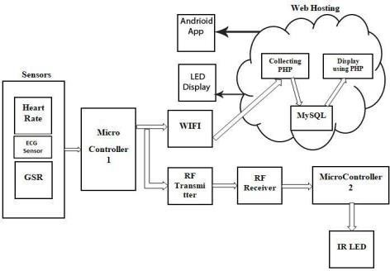Stress Indication is completed within the first Microcontroller using sensors and sends wireless signal to the RF Receiver within the second Microcontroller through RF Transmitter. Once the signal is received in second microcontroller, it'll turn on the IR LED to scale back the strain level which is attached within the user toe

## SYSTEM ARCHITECTURE IV.IMPLEMENTATION DETAILS

*A. HARDWARE DETAILS*

Hardware tools used in the project are Microcontroller ,heart rate sensor, Galvanic skin response(GSR), Electrocardiogram (ECG) sensor, RF Transceiver, Infra red LED

1. *MICROCONTROLLER*

Arduino IDE is open source software available for programming an Arduino board. It runs on any operating system such as Windows, Linux or MAC OS X. The data collection is performed using an “analogRead” function which enables the Arduino board to read an analog input pin to which the sensor is connected. enables Arduino board to IoT platform Wi-Fi module in the program

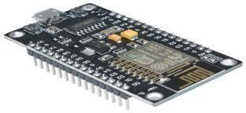

1. *HEART RATE SENSOR*

Heart beat sensor is designed to give digital output ofheat beat when a finger is placed on it. When the heart beat detector is working, the beat LED flashes in unison with each heart beat. This digital output can be connected to microcontroller directly to measure the Beats Per Minute (BPM) rate. It works on the principle of light modulation by blood flow through finger at each pulse

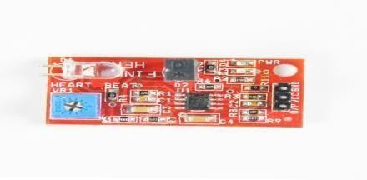

1. *GALVANIC SKIN RESPONSE SENSOR*

Galvanic skin response readings are simply the measurement of electrical resistance through the body. Two leads are attached to two fingertips. One lead sends current while the other measures the difference. This setup measures GSR every 50 milliseconds. Each reading is graphed, while peaks are highlighted and an average is calculated to smooth out the values. A baseline reading is taken for 10 seconds if the readings go flat (fingers removed from leads).

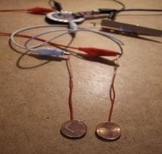

***D****.ELECTROCARDIOGRAM*

ECG Monitor Sensor Module is based on AD8232 Analog Device IC. This is a cost-effective ECG Sensor used to measure the electrical activity of the heart. This electrical activity can be charted as an ECG or Electrocardiogram and output as an analog reading. ECGs can be extremely noisy, out AD8232 Single Lead Heart Rate Monitor acts as an op amp to help obtain a clear signal. This sen- sor can be connected to an Arduino/Raspberry Pi, etc. Sample codes are easily available on the internet.

The AD8232 is an integrated signal conditioning block for ECG and other biopotential measurement applications. It is designed to extract, amplify, and filter small biopotential signals in the presence of noisy conditions, such as those created by motion or remote electrode placement The AD8232 module breaks out nine connections from the IC that you can solder pins, wires, or other connectors to. SDN, LO+, LO-, OUTPUT, 3.3V, GND provide essential pins for operating this monitor with an Arduino or other development board. Also provided on this board are RA (Right Arm), LA (LeftArm), and RL (Right Leg) pins to attach and use yourown custom sensors. Additionally, there is an LED indicator light that will pulsate to the rhythm of a heart beat.

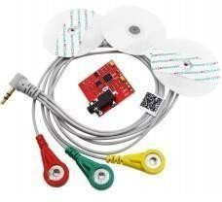

*e. RF TRANSCEIVER*

This hybrid RF Transceiver Module provides an entire RF transmitter and receiver module solution which may be wont to transmit data at up to 3KHz from any standard CMOS/TTL source.The transmitter module is extremely simple to work and offers low current consumption (typical. 11mA).Data are often supplied directly from a microprocessor or encoding device, thus keeping thecomponent count and ensuring a coffee hardware cost.The RX – ASK is an ASK Hybrid receiver module. The RF Transmitter Re- ceiver Module is an efficient low-cost solution for using 433 MHz. The TX-ASK is an ASK hybrid transmitter module. TX-ASK is meant by the saw resonator, with an efficient low cost, small size and straightforward to use for designing.

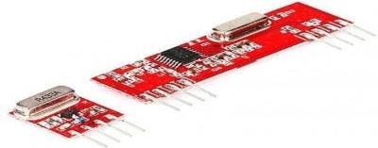

*F. IR LED*

Infrared (IR) radiation is electromagnetic radiation with wavelengths between 760 nm and 100,000 nm.Here we are using ir led with wavelengths between 9000nm and 12000 nm. infrared light also improves the circulation of oxygen-rich blood in the body, pro- moting faster healing of deep tissues and relieving pain.It also helps to relieving stress.

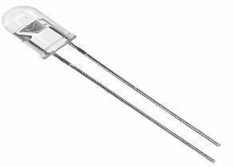

*B.SOFTWARE DETAILS*

Software Elements consists of Arduino IDE software for data collection and transmission and IOT platform With Wampserver for data storing.

1. *Arduino IDE*

Arduino board. It runs on any OS like Windows, Linux or MAC OS X. the info collection is performed using an “analogRead” function which enables the Arduino board to read an analog input pin to which the sensor is connected. enables Arduino board to IoT platform Wi-Fi module within the program and transmission and IOT platform .

1. *WAMP SERVER*

WampServer refers to an answer stack for the Microsoft Windows OS ,created by Romain Bourdon and consisting of the Apache web server, OpenSSL for SSL support, MySQL database and PHP programing languageand IOT platform .

## V.CONCLUSION

We developed a stress detection scheme to be utilized in real world. Since our system “STRESS DETECTOR AND REDUCER WEARABLE DEVICE USING IOT” employs unobtrusive wearable devices, it can easily be utilized in the lifestyle of people. It can track the strain in real-time and intervene if an extreme of stress is detected. After the detection, some stress management methods also can be offered to alleviate the high level of stress.

## REFERENCES

1. Nurdina Widanti; Budi Sumanto; Poppy Rosa; M. Fathur Miftahudin Automatic Stress Detection Using Wearable Sensors and Machine Learning: A Review,2020.
2. Murat Yuksel; Wei Wang; Shafaq Chaudhry; Damla Turgut; Naim KapucuChallenges and Opportunities in Utilizing IoT-Based Stress Maps as a Community Mood Detector,2019.
3. Bhagyashree Shirke; Jonathan Wong; Kiran George. Acute Mental Stress Measurement using Brain-IoT System ,2019.
4. Vasilii G. Arkhangelsk Sergey A. Alyushin Alexander V. AlyushinDevelopment and Analysis of Analog-Digital Neural Net for Speech Stress Detection,2018.
5. LaavanyaRachakonda;PrabhaSundaravadivel;SarajuMohanty;Elias Kougianos; Madhavi Ganapathiraju. A Smart Sensor in the IoMT for Stress Level Detec- tion,2018